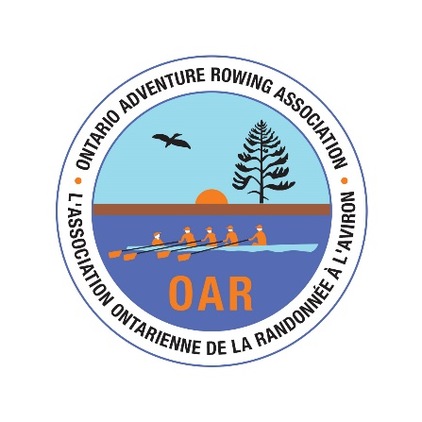

Registration Form for Kawartha Lakes Tour
June 25, 2022

Name: ________________________________________

Street or P.O. Address_____________________________
City _________________ Province ______________ Postal Code ____________
Phone number: Cell: _________________ Other: __________________
E-mail address: ______________________

Emergency contact: Name: ___________________________________________
Phone Number: ____________________________________

Club/Association affiliation: __________________ RCA number: ____________

Fee: Please send $50 fee via interac e-transfer to Richard at vincric@rogers.com.

Assumption of Risk, Liability Waiver, and Covid Conduct Agreement

Assumption of risk: I recognise that the use of the facilities and services of Ontario Adventure Rowing (OAR) as well as rowing and related activities involve potential risks. Risks include, but are not limited to, injury from collision with another vessel or stationary objects and from the malfunctioning of equipment and injury or drowning as a result of capsizing or being swamped by waves from passing vessels, adverse weather, or lock operations. I also understand that the physical exertion of rowing, including carrying boats in and out of the water, can result in injury or death.

Liability Waiver: I undertake, in my personal capacity and on behalf of those whom I represent or have custody of, and my heirs and assigns, to indemnify and save harmless Ontario Adventure Rowing, their officers and other representatives, and their successors, heirs and assigns, from and against all claims, damages, loss, costs and expenses relating to any injury including death, or loss of or damage to my or any third party's property arising out of or being incidental to my presence at the event.

Covid: I certify that I will obey all Covid public safety regulations and obey the OAR’s COVID Protocol. I have received two doses of Covid-19 vaccines approved by Health Canada.

Fitness to row: I am an experienced sculler, and I am fit enough to row 30 km in one day, and I can swim 50 m.
OAR Membership: I am a member of OAR (either individually or through my club).
The following rowing clubs were members of OAR in September 2021: Argos, Barrie, Cambridge, Cornwall, Don, Durham, Hanlan, Hatchets, Guelph, Niagara Rowing School, ONEC Rowing, Orillia, Peterborough, Quinte, Sudbury.

(If you are not a member of OAR, you can join OAR as an independent member for $80. See www.adventurerowing.ca)

__________________________ _____________________________ ____________
Signature Printed Name Date

